AMOSO Opportunities Fund Application
High-quality low-cost open-access medical hardware for London, Ontario and beyond

Purpose
This project will start a major initiative to create and disseminate high-quality low-cost open-access medical equipment that has been approved by Health Canada for wide use and dissemination in London, in Ontario and around the globe in low- and middle-income communities.
We will research, develop and deploy ubiquitous but unnecessarily expensive devices for use both in Canada and internationally. The project philosophy is to open access to all work, data and procedures done by the team as well as access to software and hardware plans of finished products (see https://github.com/GliaX for a proof of concept). These efforts will enable local and global hospitals and ministries of health to build their own high-quality, safe and affordable medical devices, improving the standard of health care worldwide.
This work meets several academic and institutional goals. It allows for the cost-reduction of important and ubiquitous devices; it engages disadvantaged communities locally and globally; and it fosters and increases biomedical engineering expertise locally.

Background
While some physicians can afford expensive medical devices, the high cost of modern medical diagnostic and therapeutic devices renders them inaccessible to solo clinics, junior physicians and students, nurses and other allied professionals. In some low-resource institutions, there may be fewer devices than are needed. In low- and middle-income communities, devices are often completely unavailable. This results in a reduction of the standard of health care compared to richer institutions.
The project aims to combat this asymmetry of care by providing physicians with access to high-quality/low-cost medical equipment via an open-access model. We piloted this concept by first tackling the stethoscope, a piece of medical hardware that is both ubiquitously used and technically attainable.
The open access stethoscope is a mature proof-of-concept for this project’s model. The stethoscope is a simple instrument that has undergone little innovation in design or fabrication since Dr. David Littmann patented his model in 1963. Despite this, the Littmann Cardiology III, which is widely regarded as the field’s gold standard, still costs several hundred dollars. This cost is a barrier in Ontario and the developed world to junior doctors and students as well as allied professionals like nurses. The cost also makes these high-quality devices completely inaccessible to medical staff in the developing world.
Modeling off the 1963 Littmann design whose patent expired decades ago, we are able to create a stethoscope that performs on par with the Cardiology III (using a chest wall phantom and analyzing spectral analysis between models) at a cost of 2.83 USD (images and supporting data included in Appendix A). To keep costs low, 3D printers are used to create several parts including the bell, Y piece, and ear tubes. This device has been tested rigorously and is certified by Health Canada as a class I device. The device has received interest from countries such as Nicaragua, Mexico, Singapore and Rwanda, and is currently being deployed in the Gaza strip, an area with extremely limited access to medical devices. At this time, hospitals in Gaza are self-sufficient producers of these stethoscopes, using recycled plastic to create them. We hope to continue trials at London Health Sciences Centre (LHSC) to improve the device’s functionality and ease of production. Several staff in the Division of Emergency medicine already use these stethoscopes.
Another widely used medical device in high-income countries is the pulse oximeter – a device used to assess a patient’s oxyhemoglobin saturation in both clinical and surgical settings. In developed countries, pulse oximetry is the standard modality of alerting physicians to hypoxemic patients during anesthesia1,2, pneumonia3,4 and acute respiratory distress syndrome5. Gold standard Nellcor pulse oximeters currently cost in the range of USD$1000, making it an unobtainable piece of equipment for rural and solo Ontario clinics as well as low- and middle-income countries’ medical systems.
This important issue has been recognized by the World Health Organization (WHO), who estimate that low- and middle-income countries are in need of one million pulse oximeters and have initiated the Global Pulse Oximetry Project6. Recent studies also suggest that, in the surgical setting, only 41-70% of operating rooms in low- and middle-income countries have access to a pulse oximeter during surgery, compared with 100% in high-income countries7.
To fill the gap both in Ontario and internationally, this project aims to design a Health Canada approved pulse oximeter that meets USA Food and Drug Administration (FDA) 501(k) standards for use in global clinics and operating rooms at a cost of USD$25. Like the stethoscope, all designs, software and calibration tables will be made openly available.
The third device within the scope of this project’s timeline is the electrocardiogram (ECG), a device that, since its advent in 1901, remains the standard of care in the developed world for detecting cardiac pathologies such as arrhythmias, ischemia and hypertrophy with high sensitivity. Access to ECG tests in many rural and solo Canadian clinics continues to be low. Low- and middle-income countries have access to these devices in urban hospitals and clinics, but like in Ontario, rural areas in these countries suffer from a lack of access8.
This issue is compounded by the high initial cost of ECG machines, which retail at several thousand dollars, and the complex nature of ECG interpretation9. However, following the initial purchase of an ECG, individual tests are inexpensive and noninvasive. The goal for our project’s ECG is a device that costs in the range of USD$300-500 and is approved by Health Canada in design and validation. By providing designs for hospitals, clinics and ministries of health in Canada and abroad, we can bridge the unacceptable disparity of access between urban and rural patients.
With AMOSO Opportunities Fund support, we will be able to distribute our finished stethoscope project using an open-access model of delivery as well as calibrate, validate and deploy the pulse oximeter in the LHSC emergency department. We will also create, validate and deploy ECG devices.
Following the end of this project, we will continue to design needed medical devices which are unnecessarily expensive. Targets include upper limb prosthetics and hemodialysis machines, which retail for thousands and tens of thousands of dollars respectively, but can be produced for a fraction of the cost. Making available low-cost hemodialysis machines that are equal in quality to the gold-standards will change prosthetic and dialysis management in Ontario and abroad.

Project Description
The strategy of this project is to create and disseminate high-quality, safe and low-cost medical equipment through several steps which are common to most devices:
- Device Design: Devices will be designed based on publicly available documents, expired patents, previous published research and hobbyist efforts found online. Depending on device complexity, this process may be led by biomedical engineers or designers.
- Prototype Creation: Rapid prototyping techniques such as 3D printing, home CNC and laser-cutting allow many iterations of devices in a short period of time, cutting costs and decreasing development time for devices.
- Experimental calibration and validation: Once devices are designed, they must be experimentally calibrated and validated to ensure that they function and perform as expected when compared to a gold-standard.
- Health Canada/FDA approval: Devices must pass regulatory approval so they can be ethically used by patients in Ontario hospitals such as LHSC. This additional layer of scrutiny will ensure the safety and effectiveness of the device.
- Publication in an open access journal: All designs, protocols and data will be shared openly with the medical community via open access journals.
- Assembly instruction: Instructions on how to assemble and test the device will be prepared via video and written instruction.
- Knowledge translation and product deployment: We will help interested institutions (such as LHSC) and ministries of health to safely manufacture and deploy these devices as part of the knowledge translation component of this project.
Throughout all steps of this process, designs, data and documents will be made openly available online ( https://github.com/GliaX ). Design considerations will include cost, availability of parts, ease of construction, quality, ease of maintenance and ease of use.
The “Glia stethoscope” (named for the informal name of the project) is a pilot of this model, and is currently ready for publication and deployment. Empirically, we have shown that our stethoscope is equivalent to the Littmann Cardiology III, the field’s gold standard, using a chest wall phantom and measuring the frequency responses of each stethoscope. This data and a bill of materials are included in Appendix A.
Ultimately, however, the quality of a stethoscope is subjectively determined by the user through experience with the device. Therefore, the stethoscope continues to be trialed in Gaza and we are currently preparing to create 500 stethoscopes to trial at LHSC to receive feedback on our design. The final design will then be made openly available for production by hospitals and ministries of health in Canada and worldwide.
The pulse oximeter is the next project we aim to complete. For the pulse oximeter to be completed, we must finish engineering the device, clinically calibrate and validate the device on human subjects (ethics approval has been obtained), and then publish findings and deploy the device at LHSC’s emergency department. A bill of materials for the pulse oximeter can be found in Appendix B demonstrating the potential cost-savings over the gold standard Nellcor, which has a USD$1000 pricepoint.
Calibration of the device will follow the ISO-80601-2-61 controlled desaturation study protocol. This protocol involves obtaining blood gas samples, oximeter readings as well as CO-oximeter readings at room air, 100% O2 and at serially reduced SpO2 ranges of 96-92%, 91-87%, 86-82%, 81-77%, 76-72% and 71-67%. These values, obtained in approximately 30 healthy volunteers, will be used to generate reference values for future readings. Following this, validation of the device, which includes comparing device readings against a Nellcor monitor, will occur in approximately 350 volunteers to assess oximeter accuracy. The clinical trial has ethics approval and is scheduled to start January 2017. The device will also meet FDA 501(k) standards as outlined in the FDA guidance document “Pulse Oximeters - Premarket Notification Submissions [510(k)s]: Guidance for Industry and Food and Drug Administration Staff” before Health Canada approval is obtained.
The ECG project is currently near the end of feasibility study and literature review. ECG engineering and design will have to be completed in collaboration with biomedical engineering, and validation will be done using PhysioNet, an open source database and software toolkit to acquire, test and validate known ECG signals.10,11 Like the pulse oximeter, the ECG will be validated against a gold standard ECG clinically following PhysioNet testing.
In order to keep this project cost-effective, we are using an open source model for research, software and hardware. Free/open source software (FOSS) is a well-known model and has a track record of several decades of success in mission-critical uses. Open hardware is a comparatively new concept, as the resources needed to make high quality hardware have until recently been very expensive. To our knowledge, the “Glia stethoscope” is the world’s first medical device built and released with an open hardware license.
Because we are creating this model, there are expected and unexpected hurdles. An expected hurdle is acceptance from medical professionals, administrators and traditional funders. The stethoscope project serves as a way to defuse these tensions and help explain the concept, but no doubt this issue will arise again as we introduce more complicated medical devices developed with this model.

Current Resources
The stethoscope served as a successful proof of concept of the project model and was self-funded by the Project Lead, Dr. Tarek Loubani. As the project moves forward into more complex devices, external funding is required. We will seek additional funding from foundations and peer review funding agencies in the future, once success in those competitions becomes more likely.
Personnel currently includes a project manager as well as a number of paid and unpaid consulting engineers. We are also committed to undergraduate medicine research training programs at the medical school. We currently have one medical student in the Summer Research Training Program (SRTP) and one student in the Summer Research Opportunities Program (SORP) and are in the process of recruiting one resident doctor from Schulich’s Windsor program.

Department Commitment
The Division of Emergency Medicine is committed to this project and believes in its ambitious goals to reduce the disparity to access of high quality medical devices. The Division has agreed in principle to use devices in the ER that we develop. The Devision will also allow us to use space at Victoria Hospital in London during the clinical trial of the pulse oximeter. This will include both the calibration and validation of the device. The same will be true of future devices.

Proposed Outcome Measures and Reporting
The following will represent the outcome measures, presented by year:
Year 1 (2017):
- Pulse Oximeter:
  - Complete engineering of device
  - Calibration and validation trial
  - Start Health Canada regulatory process
- ECG:
  - Complete literature review
  - Complete patent search
  - Preliminary device design
- Stethoscope:
  - Produce and deploy 500 units for LHSC division of emergency medicine
  - Complete assembly and testing documentation for end-users
Year 2 (2018):
- Pulse Oximeter:
  - Address regulatory issues that arise
  - Develop manufacturing workflow
  - Manufacture 100 units for use at LHSC Division of Emergency Medicine and Department of Anaesthesia
  - Publish results and procedures in open access medical journal
- ECG:
  - Calibrate and validate device
  - Start Health Canada regulatory process
Year 3 (2019):
- Pulse Oximeter:
  - Monitoring and continuing evaluation
  - Knowledge translation to other hospitals and ministries of health
  - Consider adding carboxy- and met-hemoglobin monitoring
- ECG:
  - Develop manufacturing workflow
  - Manufacture 10 units for use in LHSC division of emergency medicine and cardiology ward.
  - Publish results and procedures in open access medical journal

Proposed Term Commitment
This project will result in an initiative that can select and develop devices that meet the criteria of being a) unnecessarily expensive; and b) clinically valuable. After the funding term is finished, if the initiative is successful as we hope it should be, we will have enough experience and research success to request further funding from other agencies.

References
1. Walker, I. & Wilson, I. Anaesthesia in developing countries - a risk for patients. Lancet 968–969 (2009).
2. Haynes, A., Weiser, T. & Berry, W. A surgical safety checklist to reduce morbidity and mortality in a global population. New Eng J Med 491–499 (2009).
3. Duke, T., Graham, S. & Cherian, M. Oxygen is an essential medicine: a call for international action. Int J Tuberc Lung Dis 1362–1368 (2010).
4. Ashraf, H., Jobayer, M. & Alam, N. Treatment of childhood pneumonia in developing countries. (2010).
5. Kwizera, A. & Dunser, M. A Global Perspective on Acute Respiratory Distress Syndrome and the Truth about Hypoxia in Resource-limited Settings. Am. J. Respir. Crit. Care Med. 5–7 (2016).
6. WHO. Global Pulse Oximetry Project. (2008).
7. Funk, L., Weiser, T. & Berry, W. Global operating theatre distribution and pulse oximetry supply: an estimation from reported data. Lancet 1055–1061 (2010).
8. Bagchi, S. Telemedicine in rural India. PLoS Med e82 (2006).
9. Varma, N. Role of the surface electrocardiogram in developing countries. J. Electrocardiol. 612–614 (2010).
10. Silva, I. & Moody, G. An Open-source Toolbox for Analysing and Processing PhysioNet Databases in MATLAB and Octave. J. Open Res. Softw. 2, (2014).
11. Costa, M., Moody, G., Henry, I. & Goldberger, A. L. PhysioNet: an NIH research resource for complex signals. J. Electrocardiol. 36, 139–144 (2003).
Appendix A
Item | Dimensions | Cost (USD)
Stethoscope head | 44.30mm x 62.45mm x 17.80mm | $0.206
Stethoscope Y piece | 70.89mm x 29.94mm x 9.00mm | $0.09
Stethoscope ear tube | 170.79mm x 83.62mm x 5.80mm | $0.07
Stethoscope ring | r = 21mm, h = 7mm | $0.012
Stethoscope spring | 91.25mm x 111.62mm x 15.05mm | $0.032
Silicone tubing | 40 cm – 12mm OD, 8mm ID / 2x 9 cm – 6mm OD, 4 mm ID | $1.93
Diaphragm | r = 20mm | $0.06
Ear plugs with mold | n/a | $0.43
Total |  | 2.83
Table 1. Bill of materials for the Glia model stethoscope (100% infill)
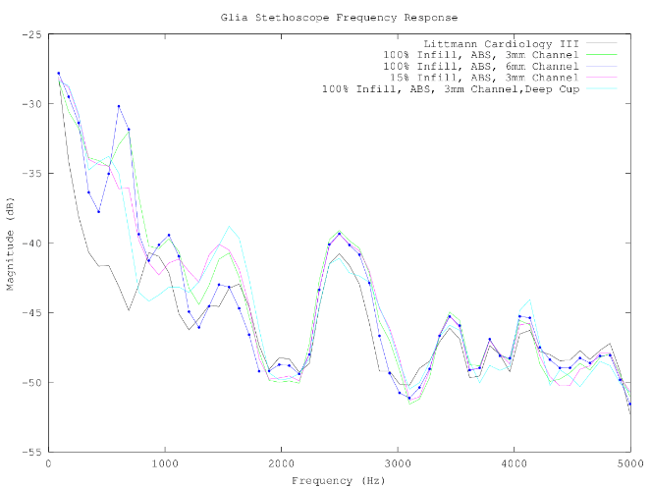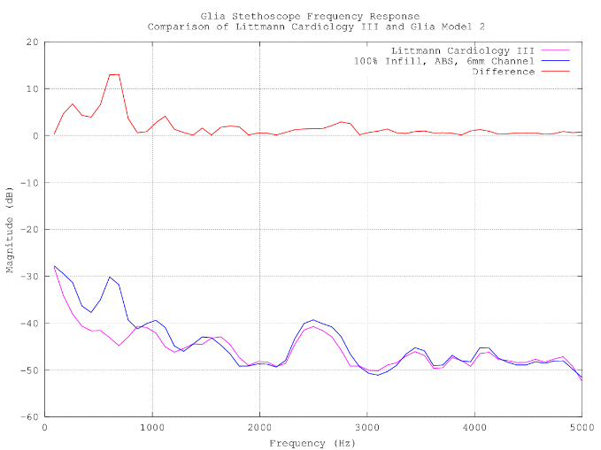
Calibration and comparison of 3D printed Glia model stethoscopes to the gold standard Littmann Cardiology III. Stethoscope output responses were measured using the equipment setup described in the methods. Each stethoscope model recorded input sound at multiple frequencies and the change in amplitude between input and recorded sound was documented for each stethoscope. Further comparison between the Glia Model 2 and the gold standard Littmann Cardiology III is shown in with the absolute Δmagnitude plotted above.
Appendix B
Item | Cost (CAD)
Infrared Emitter 940nm | 0.38
640nm LED | 0.77
25x Header and Wire House Connector | 4.00
Light To Frequency & Light To Voltage Converter | 2.06
FFC & FPC Connectors | 1.44
ARM Micrrocontrollers | 1.96
Fixed Inductors WE-TPC 2811 | 2.07
Speakers & Transducers | 2.71
Voltage Regulators | 0.90
2x Tactile Switches | 0.67
3x Thick Film Resistor 1/20watt 1Mohms | 1.13
Thick Film Resistor 1/10watt 590Kohms | 0.15
Thick Film Resistor 1/10watt 2.0Kohms | 0.15
LDO Voltage Regulator | 0.58
4x Multilayer Ceramic Capacitors – MLCC SMD/SMT 0603 0.1uF 16V | 0.58
2x Multilayer Ceramic Capacitors MLCC – SMD/SMT 6.3V 10uF | 0.55
2x Multilayer Ceramic Capacitors MLCC – SMD/SMT 0603 4.7uF 6.3V | 0.32
9x Multilayer Ceramic Capacitors MLCC – SMD/SMT 0603 1uF 10V | 1.31
LCD w/Touch Panel | 4.7
Total | 26.43
Table 2. Bill of Materials for the Glia Pulse Oximeter

